**Practical Assignment**

Class : Bca(AI\ML) 1B

NAME=sahil kumar

Group:1

Q1= **Create a simple html tag using basic tags?**

<HTML>

<HEAD>

<TITLE> HELLO WORLD </TITLE>

</HEAD>

<body>

<H1> Your Name </h1>

</Body>

</html>

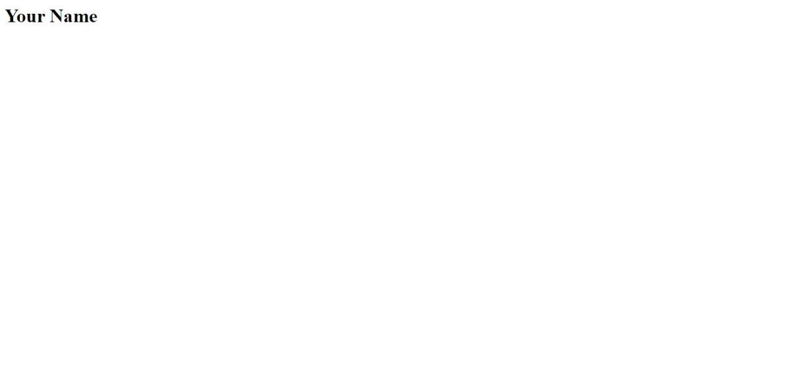

Q2= **Create a web page that displays your name to the screen?**

**Ans=**

**<HTML>**

**<HEAD>**

**<TITLE> HELLO WORLD </TITLE>**

**</HEAD>**

**<body>**

**<H1> RIAZ MOHD </h1>**

**</body>**

**</html>**

= output



**Q3= Create a web page and show the output from 1 to 10 in separate lines?**

<HTML>

<HEAD>

<TITLE> HELLO WORLD </TITLE>

</HEAD>

<body>

1<br> 2<br> 3<br> 4<br> 5<br> 6<br> 7<br> 8<br> 9<br> 10<br>

</body>

</html>

**=OUTPUT**

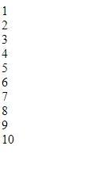

**Q4= Create a webpage and show the output from 1 to 10 in separate lines, each number being in different color?**

<HTML>

<HEAD>

<TITLE> HELLO WORLD </TITLE>

</HEAD>

<body>

<font color="red"> 1 </font><br>

<font color="blue"> 2 </font><br>

<font color="green"> 3 </font><br>

<font color="black"> 4 </font><br>

<font color="brown"> 5 </font><br>

<font color="pink"> 6 </font><br>

<font color="orange"> 7 </font><br>

<font color="purple"> 8 </font><br>

<font color="grey"> 9 </font><br>

<font color="yellow"> 10 </font><br>

</body>

</html>

**=OUTPUT**

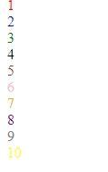

**Q5= how to make a picture as a background on my web pages?**

ANS= <HTML>

<HEAD>

<TITLE> HELLO WORLD </TITLE>

</HEAD>

<body>

<body background="C:\Users\student\Downloads/download.jpg">

</body>

</html>

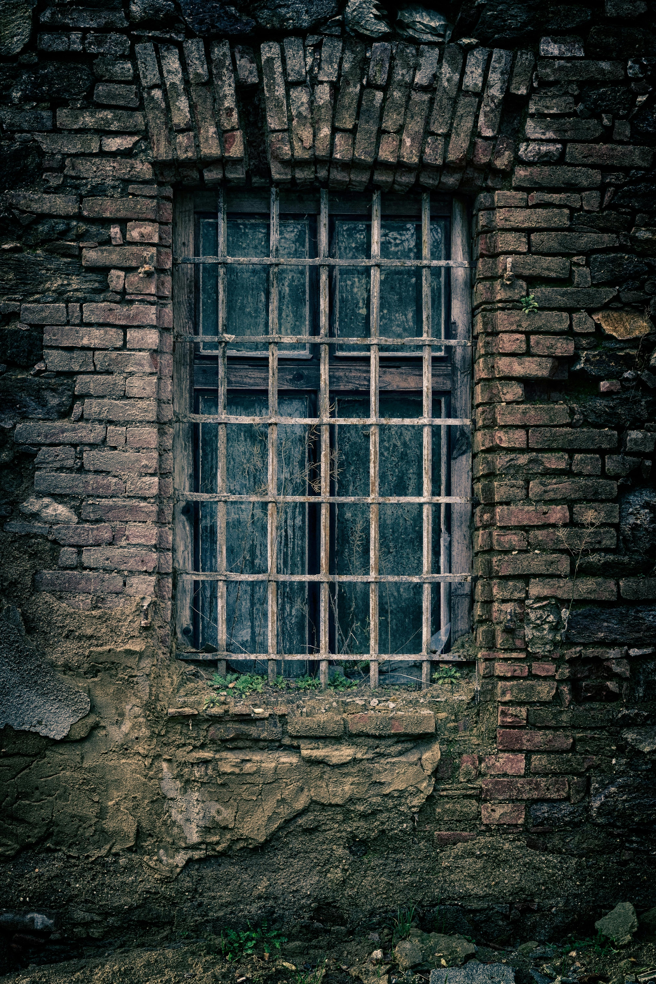

**= OUTPUT**

**Q6=Create a web page to print a paragraph with 4-5 sentences, each sentences shall have a different font?**

**Ans=**

**<!DOCTYPE html>**

**<html>**

**<head>**

**<title>Paragraph with Different Fonts</title>**

**<style>**

**.font1 { font-family: Arial; }**

**.font2 { font-family: 'Courier New'; }**

**.font3 { font-family: Georgia; }**

**.font4 { font-family: Tahoma; }**

**</style>**

**</head>**

**<body>**

**<p class="font1">This is the first sentence with Arial font.</p>**

**<p class="font2">This is the second sentence with Courier New font.</p>**

**<p class="font3">This is the third sentence with Georgia font.</p>**

**<p class="font4">This is the fourth sentence with Tahoma font.</p>**

**</body>**

**</html>**

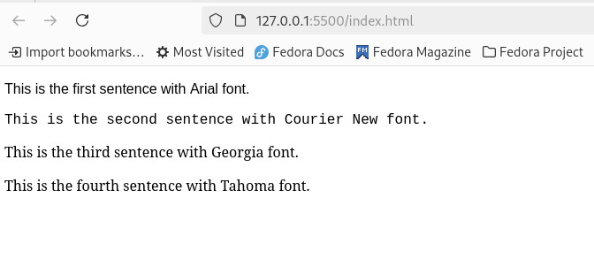

**= OUTPUT**

**Q7=write HTML code to print a paragraph that is described of a book, it shall include the title should be underlined and all adjectives shall be bold and italics?**

<HTML>

<HEAD>

<TITLE>BOOK </title>

</head>

<Body>

<H1><u><b> Title Of The Book: Ramayan</b></u></H1>

<p><i> Author Name: Valmiki <br></i>

<i>India is well-known for its rich culture, traditions, mythological stories, and religious diversity worldwide. Stories like Ramayana are prevalent in the sensibilities of Indian people and play a vital role in preaching the overall ideal way of living in the world. It is an epic that strengthens the importance of brotherhood, sacrifices for loved ones, a sense of righteousness, culture, humbleness, and simple living with a touch of sacredness. Ramayana is much more than a mythological tale that teaches us about our heritage and some of history’s most significant events. Children should be taught these stories from an early age since it helps them understand Indian history much better. The Ramayana story in English is taught in many elementary schools as part of the curriculum. The Ramayana’s full story is of prince Rama’s journey with the help of an army of monkeys to rescue his beloved wife, Sita, from the hands of the great monarch of Lanka, Ravana. Learn more by reading ahead.

.</i></P>

</p>

</body>

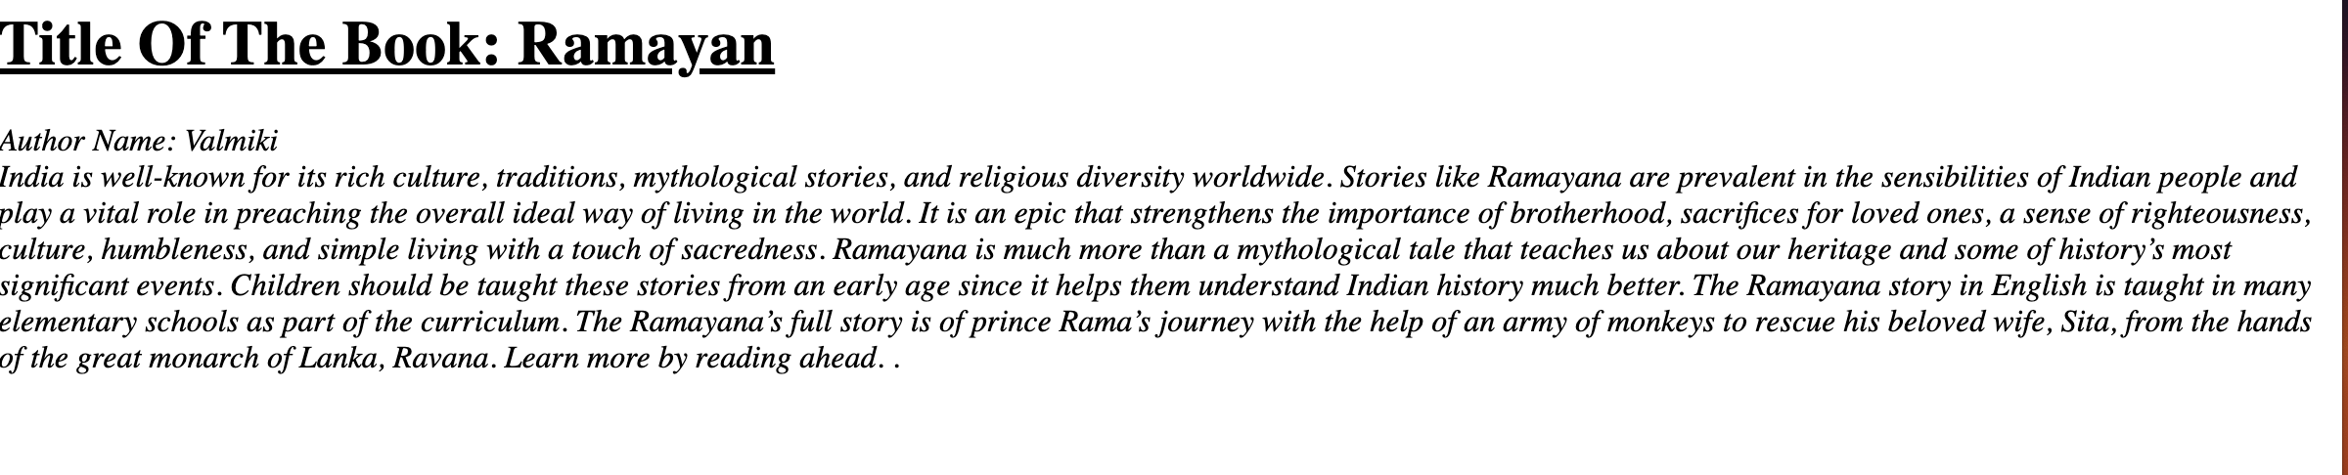

**Q8: Write HTML code to print your name using heading tag, every letter shall be of different heading size?**

**<H6> O</h6>**

**<H1> H</h1>**

**<H2> D</h2>**

**</body><HTML>**

**<HEAD>**

**<Title> RIAZ </Title>**

**</HEAD>**

**<BODY>**

**<H1> S</h1>**

**<H2> A</h2>**

**<H3> H</h3>**

**<H4> I</h4><br>**

**<H5> L</h5>**

**<H6> L</H6>**

**</html>**

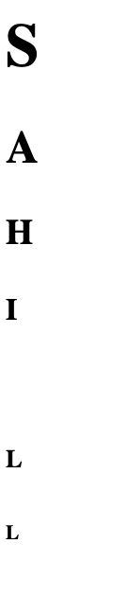

**Q9:Write Html code to print the sequence of number 1-20. each no shall be in different line with number 2 next to it as subscript, an equal sign and the result?**

**Ans:** <html>

<head>

<title>Number Sequence</title>

</head>

<body>

<p>1<sub>2</sub> = 1</p>

<p>2<sub>2</sub> = 4</p>

<p>3<sub>2</sub> = 9</p> <p>4<sub>2</sub> = 16</p> <p>5<sub>2</sub> = 25</p> <p>6<sub>2</sub> = 36</p> <p>7<sub>2</sub> = 49</p> <p>8<sub>2</sub> = 64</p> <p>9<sub>2</sub> = 81</p>

<p>10<sub>2</sub> = 100</p> <p>11<sub>2</sub> = 121</p> <p>12<sub>2</sub> = 144</p> <p>13<sub>2</sub> = 169</p> <p>14<sub>2</sub> = 196</p> <p>15<sub>2</sub> = 225</p> <p>16<sub>2</sub> = 256</p> <p>17<sub>2</sub> = 289</p> <p>18<sub>2</sub> = 324</p> <p>19<sub>2</sub> = 361</p> <p>20<sub>2</sub> = 400</p> </body>

</html>

Output:

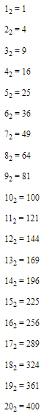

Q10. wtrite an html code to display an image with border of size with width 200 height 200 pixels , leaving Hspace and Vspace of your choice with image hanging in the right side on the screen.

Ans: <HTML>

<head>

<title>Image Display</title>

<style>

img {

border: 2px solid black;

width: 250px;

height: 250px;

display: block;

margin-left: auto;

margin-right: 0;

margin-top: 20px;

margin-bottom: 20px; }

</style>

</head>

<body>

<img src=unsplash.jpghttps://www.google.com/url?sa=i&url=https%3A%2F%2Fwww.pinterest.com%2Fpin%2F231724343307169697%2F&psig=AOvVaw3ozMlvSXgSuQpF4JVPlenD&ust=1729869353155000&source=images&cd=vfe&opi=89978449&ved=0CBQQjRxqFwoTCIDFxOOnp4kDFQAAAAAdAAAAABAE" alt="Sample Image">

</body>

</html>

Output:

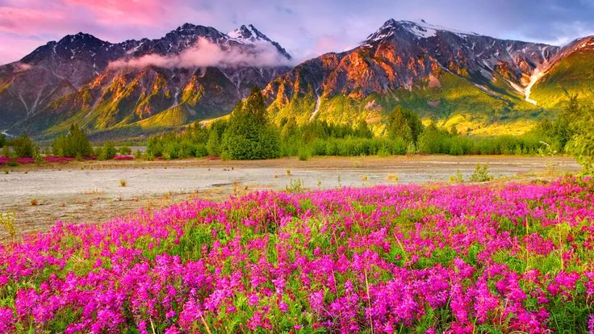

Q11: write a html code to create a web page with heading. the heading shall be displayed at the top-centre of the page and the image shall be at the centre , just below the heading .

INPUT- <html>

<head>

<title>Centered Heading and Image</title>

<style>

body {

margin: 0;

font-family: Arial, sans-serif;

text-align: center;

justify-content: center;

align-items: center;

</style>

</head>

<body>

<h1>The mounten</h1>

<img src="C:\Users\sahil\Downloads/riaz.jpg" alt="scenery" height="450" , width='450'>

</body>

</html>

Output:

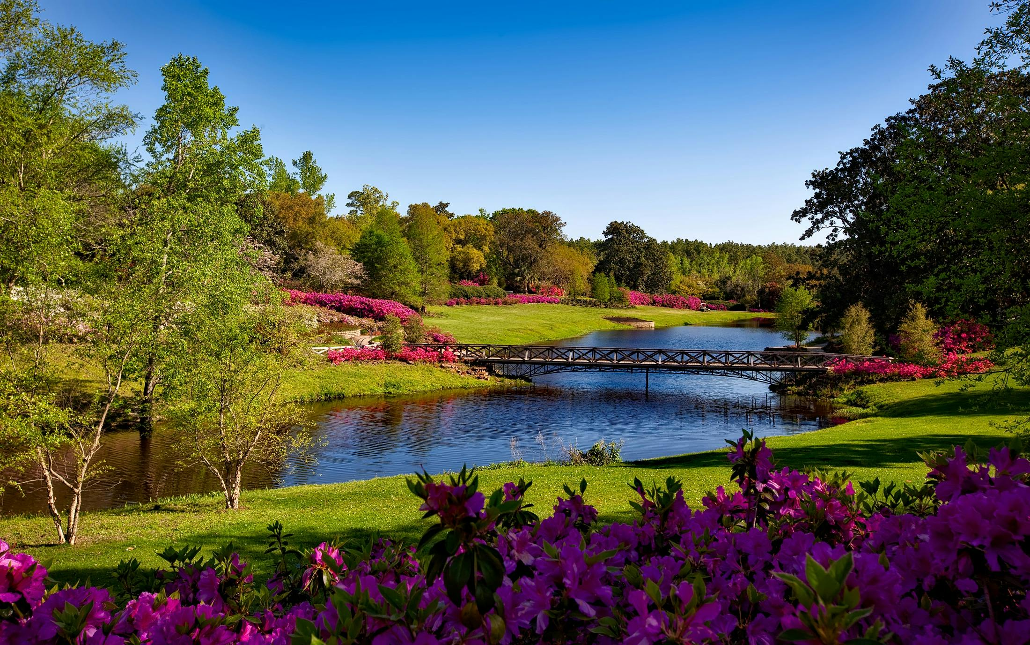

Q12. Write HTML code using Multimedia tags.

<html>

<head>

<title> multimedia tags</title>

</head>

<body>

<h1> multimedia tags: </h1>

<h1>img</h1>

<center>

<img src="C:\Users\sahil\Downloads/riaz.jpg" alt="scenery" height="450" , width="450"/>

<h1> audio </h1>

<audio src="C:\Users\sahil\Downloads/ringtone.mp3" controls/>

</body>

</html>

Output:

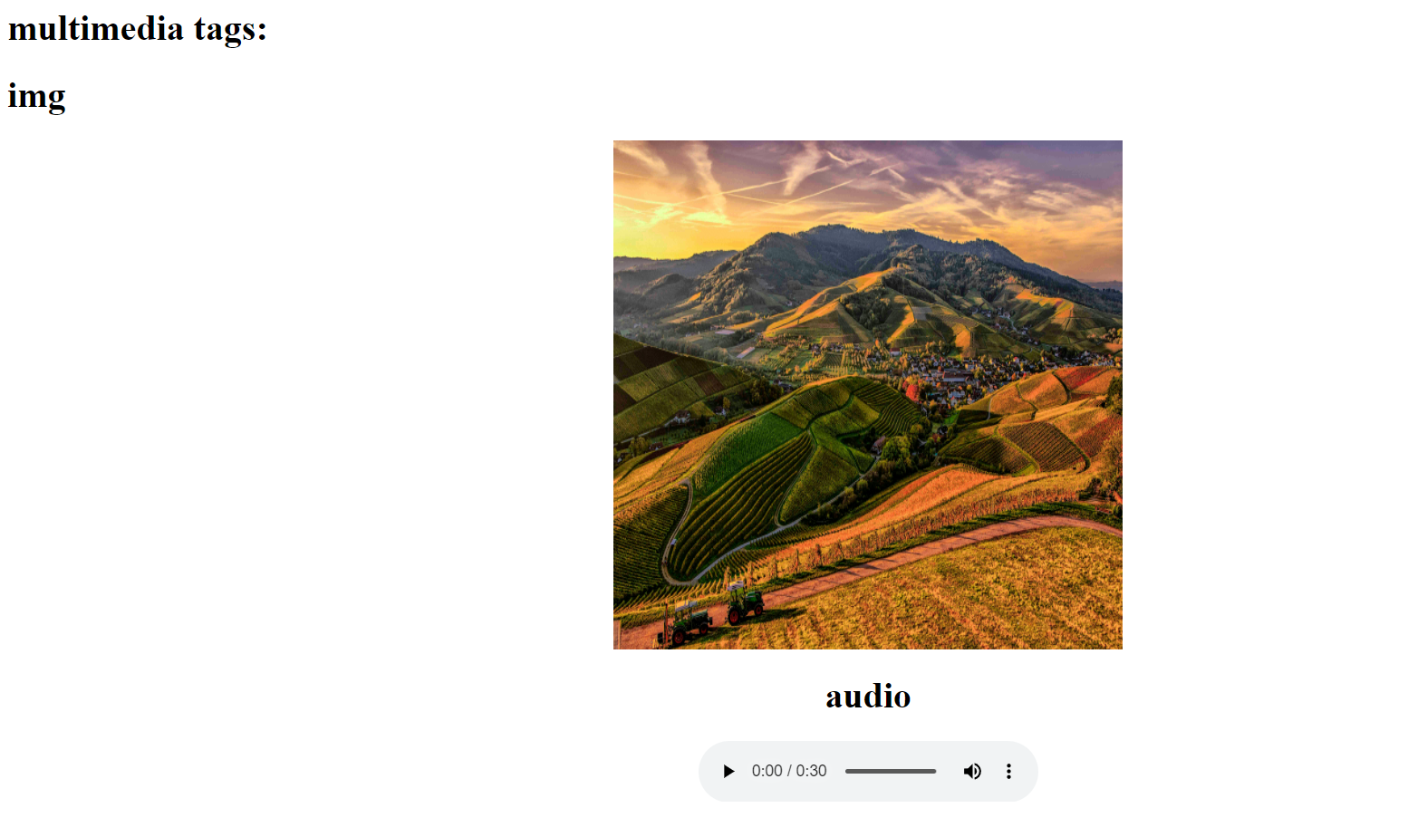

**Video tag:**

**<html>**

**<head>**

**<title> multi media tags</title>**

**</head>**

**<body>**

**<video src="C:\Users\sahil\Downloads/vidio.mp4" width="720" heigth="480" alt="vidio" controls="control">**

**</video>**

**</body>**

**</html>**

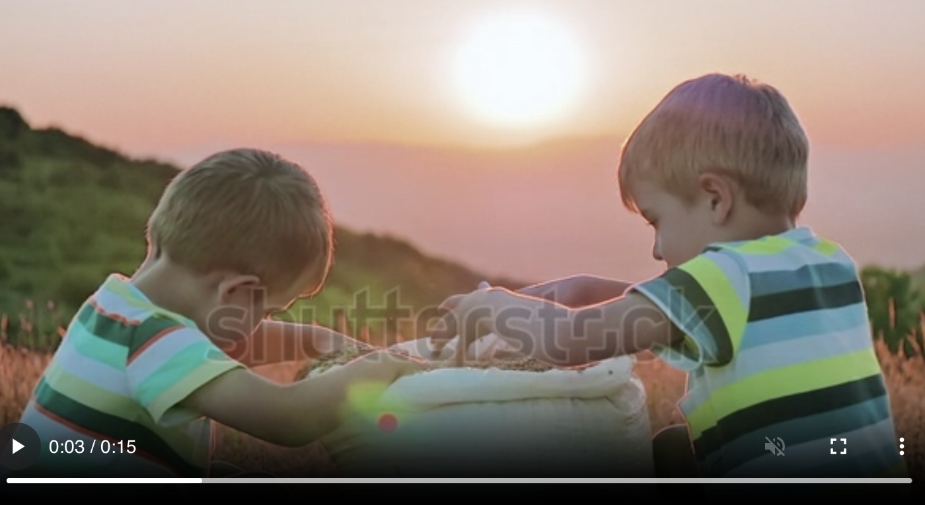

**Q13:** **Create a Table using Rowspan and Colspan taking example of student Record?**

**Ans:**

1. **rowspan**

**<html>**

**<head>**

**<title> my world </title>**

**</head>**

**<body>**

**<h1> table </h1>**

**<table border="2">**

**<tr>**

**<th> name</td>**

**<th> roll no</td>**

**</tr>**

**<tr>**

**<td >sahil</td>**

**<td rowspan="2">77</td>**

**</tr>**

**<tr>**

**<td> pappi</td>**

**</tr>**

**</table>**

**</body>**

**</html>**

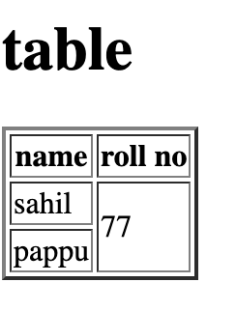

Colspan:

<html>

<head>

<title> my world </title>

</head>

<body>

<h1> table </h1>

<table border="2">

<tr>

<th> name</td>

<th> roll no</td>

<th> class</th>

</tr>

<tr>

<td >sahil</td>

<td colspan="2">23</td>

</tr>

<tr>

<td> pappu</td>

<td> 24</td>

<td> bca </td>

</tr>

</table>

</body>

</html>

